Student ID: 103219744

Name: Abdulla Shinah

# Setup Screenshot

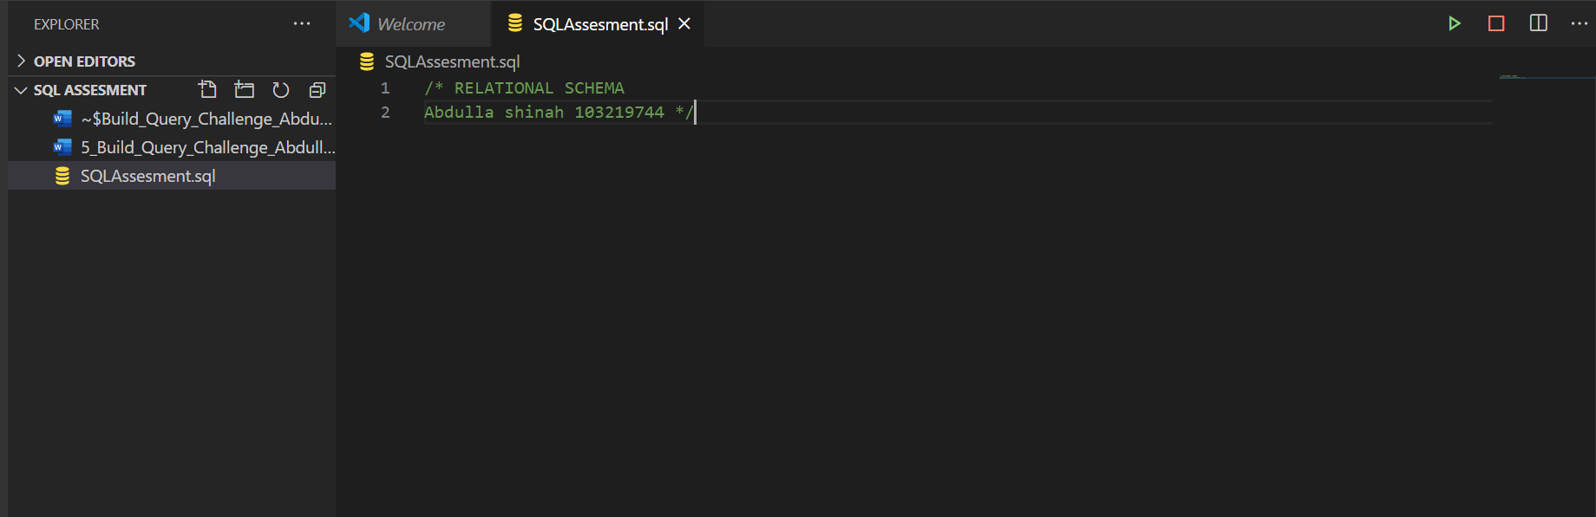

# Task 2 Screenshot

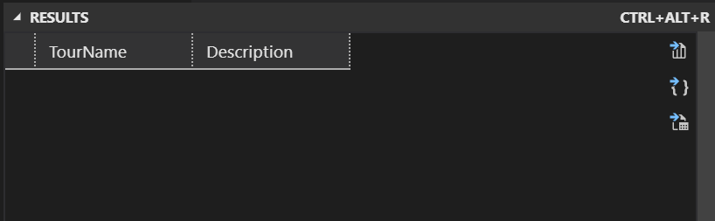

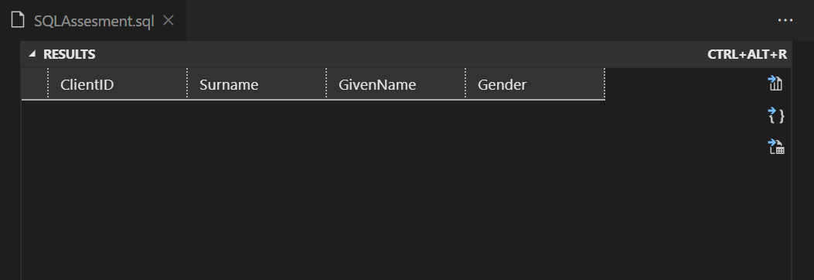

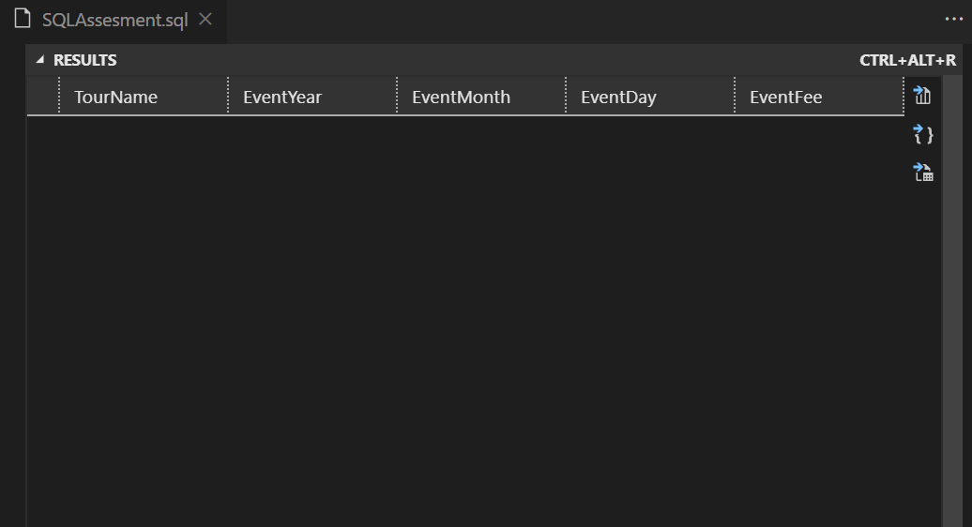

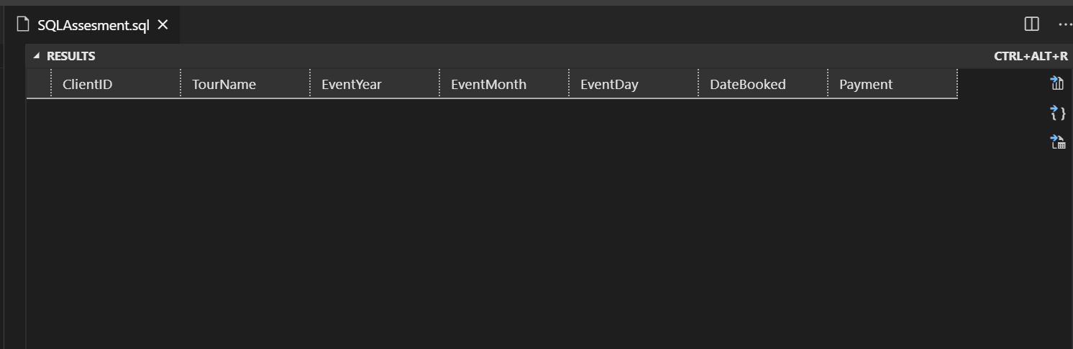

# Task 3 Screenshot

